
Loyalty Tri-V Umph
Cooperation April 2009
Friendship

President-J. Clingerman-248-788-1378 Sec.-D. Angelosanto-734-422-3501
V. President-M.Trachsel-586-484-0836 Treas.-G. Steinhauer-734-459-4471

HAPPY 72ND ANNIVERSARY TRI-V

President’s Message

When I has elected to be president, I thought writing these monthly messages was going to be very painful. As it turns out I have for the most part enjoyed writing them. One of the reasons it has been easier that I thought was the consistently good writing material the all the club members have given me. From great monthly activities, to the constantly changing good and sad news that we all experience, I have tried to bring some humor to my monthly messages and hopefully at least some of you understood my humor.

In March we elected new officers. I am very confident with Mike Trachsel being the new president, Tri-V is in good hands. I also want to congratulate the new VP, Matt VanHollebeke; the new Treasurer, John Mackson, the same old secretary, Dion Angelosanto; and the new council members, Jeff Trachsel, Bill Trachsel, and Steve Trachsel. If you haven't figured it out yet, there is a majority of Trachsels as council members.

April will be a very busy month. We will be voting on making Dave Burke a member, having the anniversary party, and having final pinochle. These are all good events and I am looking forward to all of them.

Since I became a member of Tri-V seven years ago, it has been a major part of my life. I have tried to make it to as many events as I can and was never disappointed. Tri-V is a special group that provides a strong bond of fellowship that I have not experience in any other group I have been a part of. Even though I will no longer be president, I look forward to being active for many years to come.

Your president for the last two years,
John C.

Incoming President Message

I am looking forward to serving the club as President for the next two years. I'd like to thank John Clingerman for everything he has done for the club as President for the last two years. I'm sure I am going to gain a new level of appreciation for the dedication it takes to get a president's message into the editor each month on time.
I am really excited about the future of the club. For those of you who haven't heard, we have two new prospective members: Jason Osborne who is being sponsored by Dion Angelosanto and Dave Ofiara sponsored by Bill Trachsel Jr. I hope that everyone will take a moment to get to know Jason and Dave at an upcoming event.
I look forward to seeing everyone at the Anniversary Party and Final Pinochle and wish you all a Blessed Easter.
Mike Trachsel

New Prospectives

Dave Ofiara

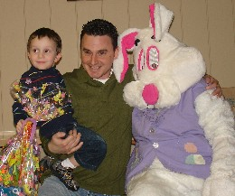
Bill Trachsel is sponsoring Dave Ofiara, a new perspective member. Bill and Dave met through their wives who worked together at Doner Advertising Agency. The girls bonded together during their first pregnancies, and the two couples have spent a lot of time hanging out together over the past few years. Dave is a father of two boys, Dominic (3 years old), and Vito (10 months). Dave and his wife Josephina live in Sterling Heights. Dave works as an electrician and is currently working on wiring a new Wal-Mart store in Monroe. In his spare time Dave enjoys spending time with his sons, bowling, playing golf, euchre, and poker. I know he will make a great addition to our Tri-V family, so please help me in welcoming him to the club.

Jason Osborne
Dion Angelosanto is sponsoring Jason Osborne. Jason and his wife April have become good friends of ours. It all started a few years ago as Ann and I began our nightly evening stroll thru the neighborhood. As Jason lives around the block, we exchanged pleasantries several times as our paths crossed. Soon our pleasantries turned into long conversations. Once Isabelle came along, we had a new addition to our friendship as we soon found out that they were expecting their daughter a few months later. Jason’s daughter Jalynn took a fast liking to Isabelle and she responded just as fast. With the girls in tow, Jason and I can be found pondering life great mysteries while playing at the park with our little princesses. Ann and April are usually discussing shopping trips and new ways to fill their scrap books (which never seem to get done). Jason is a validation engineer at Gibbs Technologies testing an amphibious assault vehicle for the military (a mix between a four wheeler & a Jet Ski). He graduated from Lawrence Tech. with a mechanical engineering degree and is currently working on his MBA. He likes to live his life by his favorite quote "The only place you will find SUCCESS before WORK, is in the dictionary" which is why he can usually be found tinkering or working on some new project (when Jalynn lets him loose). This explains that why whenever I’ve needed a helping hand, he has had no problems getting dirty right alongside me. Please help me welcome Jason and his family to our Tri-V family.
Wives Club Meeting

The Tri-V Wives meetings will continue to be held at 7:00 pm on the third Wednesday of the month. This month’s meeting is scheduled for April 15th at the home of Judy Lardin.

Book Club

The next book club meeting will be on April 27th, at 7 pm at the home of Karlyn Gies. The book to be discussed is “Plain Truth” by Jodi Piquet. All women of TRI-V and their friends and or neighbors are invited to join us in discussing the books that we've read. If you've read a book that you think would be a good book for discussion, please let one of the regular members know.

Easter Egg Hunt

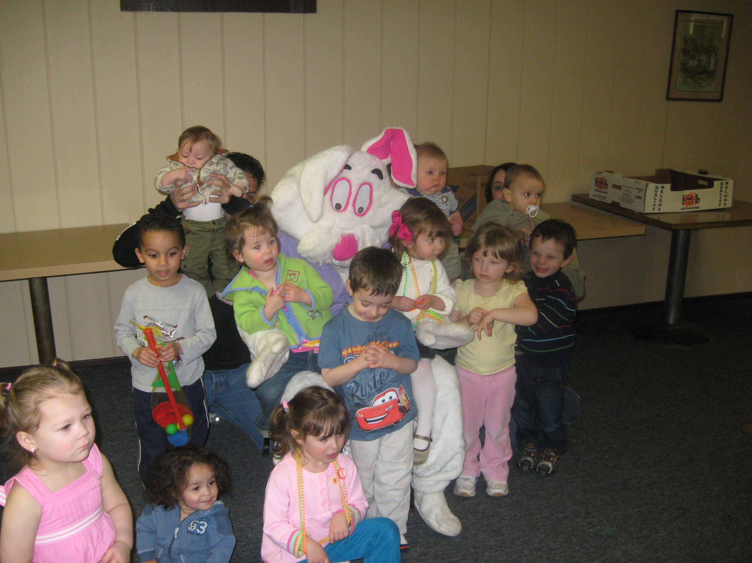
The Tri-V Easter Egg Hunt was held on March 29th and Maple Lanes Golf Club in Sterlng Heights. 21 adults and 13 children were on hand to enjoy an afternoon of fun. The Easter Bunny paid a special visit, and all the children received Easter buckets full of gifts. The kids then went outside to hunt for eggs gently hidden in the lawn outside of the clubhouse. The rain and snow that was on its way held off just long enough for all the kids to get outside and fill their buckets. All the kids had a great time. Thanks to the committee, Jeff and Bill Trachsel for organizing this event. We would also like to give a special thanks to Liz Trachsel for filling in as the Easter Bunny, she did a great job. I have a feeling this event will be staple Tri-V event for many years to come.

Final Pinochle

Final Pinochle will be held April 25th at 6 pm at Doc’s in Livonia (275 and 7 mile). Everyone is invited even if you didn’t play pinochle this year. Please contact John Mackson if you can attend or with any questions. (734) 525-0537, coachjcm@yahoo.com

Anniversary Party

I have scheduled the Anniversary party for the Maples of Novi on April 18th. Cocktails are at 6 pm. We will be entertained by the comedian Ken Ruff at 8:30 PM. We will be having a buffet dinner supplied, containing all of the below.

Fresh Seasonal Vegetables 4 Entrees
Rosemary Roasted Potatoes Mostaciolli w/Italian Sausage
Pasta w/ Parsley Butter Baked Roasted Chicken
Warm Rolls, Bread and Butter Baked Honey Glazed Ham
Slice Baron of Roast Beef
3 salads
Tossed Green (w/ 2 dressings)
Caesar
Coleslaw

Coffee, Soft Drink and Tea Service Included. There is also a cash bar available as in previous years. Cost will be between $15 and $20/person depending on attendance.

May Open House

Gateway Golf Course, Saturday, May 16, 9:00 a.m.
$66.00 per person includes golf, cart, hot dog and pop at the turn, dinner and prize money.
Sign up at the April meeting or RSVP by emailing or calling Nick. victoriadominic@yahoo.com, (734) 522-5366
TRI V GOLF LEAGUE
We're back! Same place, same time, same prize money fees, same rules and same old Committee. We start at 4:30 Monday, April 20th. Even if you don't plan to be in the prize money for 1 or both halves we'd like you to join us. Hope to see you there! Any questions contact us. Your committee, Romas & Tom
Final golf

Where: Gaylord Michigan
When: August 28th, 29th, 30th

We will be staying at Ray’s Retreat Country Inn. I have told them that we will have at least 24 people attending. I need to know if you are planning to attend and a 200.00 deposit per person by May 15th. Please let committee know as soon as possible.

Friday: The Natural
Saturday: The Wilderness
Sunday: Black Forest

Cost will be around 300.00. I will have total cost by Mid April. This will include 2 dinners and 2 breakfasts along with prize money. Ray’s Retreat is a 17 unit Inn. We will have the whole Inn. We have a room for cards at night. The Inn also has a volleyball court and horse shoes along with a bonfire each night. Hope to have a good turn out so let us know ASAP if you plan on attending. Committee: Matt VanHollebeke, Geoff Steinhauer, John Mackson, Jeff Trachsel

Tri-V Steak Roast
Please mark your calendar: Saturday, August 8, 2009 Place: Gunnar Mettala Park in Wixom

LADIES MAY DINNER

All ladies are invited to our annual May dinner on May 20th at the Bonefish Grill in Novi. Bonefish is located in the Novi Town Center Mall located at Grand River and Novi roads. We will meet at 6:00pm for lots of fun and good food. Please call Jan 248-669-9209 or Jacqui 248-349-7359. Please leave a message if we are unavailable. We need to hear from you by May 6th, as reservations must be made for our group. See you there!

Tri-V Wives Weekend Getaway
Please mark you calendars for August 28th and 29th. We will be going to the Saravilla Bed & Breakfast in Alma, Michigan. Cost should be around $50 a night. Of course there will be an expense for 2 dinners, 2 lunches and going to a place called "Loafers Glory, Village of Yesteryear. Kathie has been eaten at the Bed & Breakfast before and gone to Loafers too. She says they are really pretty good. So to ALL Tri-V Wives (not just members) or their significant other please let me know if you want to go. I would like to have a number by the middle of April before I speak to the owner again. We can have up to 18 people. I will be gone the month of March but email me your reservation. Sherry Kuhr (Committee members: Kathie Dushary, Geri Ruetenik)

ANNIVERSARY GREETINGS

From the B. Suchners
Congratulations Tri-Vers on your 72nd anniversary.
I can't believe, back in 1937, when a group of high school graduates decided to form a club that they would ever dream of it lasting 72 years, and still going. Sadly, we're down to one original member (Don Winters), us, older members could tell you of the great times and the many friends who have been brought into our lives, by being members of such a great club. Keep it going for your children, and grandchildren as we have, and remember the club motto" Use or Lose".
From the Art Trachsel
It is hard for me to realize Tri-V is 72 years old and that is 70 years ago that I was voted into the club. However it is still functioning well and our younger members are doing a great job of keeping it active and flourishing. So thank you to the current active members for keeping it healthy. May you keep it that way for many more years. Happy Birthday Tri-V

From the Cashmans
Cal & I would like to wish all of our TRI-V friends a very happy 72nd Anniversary. We enjoy being a part of this great club and look forward to being a part of the many activities that have been planned for this year. We feel so blessed to know this wonderful group of people who make up TRI-V and who have made our lives much richer and fuller than we ever thought it could be. Happy Anniversary to All.

From the Connollys
Happy Anniversary Tri V. May the club continue to carry on the traditions established by our founders. It is a privilege to be a member of such a wonderful group of people who have become an extension of our family.

From the T. Gies
Karlyn and I are down in sunny Florida for the month of March. We are staying in Del Tura near Bill and Onallee. Karlyn drove down with Bob and Sherry Kuhr and we are sharing a unit. We all attended the Florida Anniversary Party. It was so great to see so many Tri-V members together. The weather finally turned warm on Thursday and since then has been beautiful. Coming down here is so wonderful because we have our Tri-V family with us. At the anniversary we talked about why Tri-V has survived for so many years and it is the support we give each other through good times and bad, along with laughter which is noticed by all around us and is life giving. So we hope Tri-V keeps going strong because it is a gift of love to each member. See you all in April.

From Jeff Trachsel
Happy Anniversary Tri-V!! During these tough times, all of us need to realize how lucky we are to be part of such a great group of friends. This is what started this club, a group of friends. We have all had a hand in making Tri-V what it is and why it has lasted 72 years. Most people don’t have the trust, loyalty and great friends upon which this club was founded. Encourage our younger members to stay involved and to keep it going another 72 years!

From M. Myers
CONGRATULATIONS TO THE MOST UNIQUE CLUB EVER--AND MANY, MANY THANKS TO RAY FOR HIS INSIGHT SO MANY YEARS AGO!

From the Wendts
Happy Anniversary to all our friends young and old in Tri V we have had 60 great years in the club.

From the Kuhrs
Happy Anniversary!! We have been a part of Tri-V since August 1992. It has been one of the most rewarding organizations we have ever been a part of. (Bob will complain because I ended that sentence with the word of) But to call it an organization really is completely wrong. It is a great big family with God as the head. Thank for you all your friendships and support. We love you all and hope the good Lord continues to bless us with your friendships.....
From the D. Angelosantos
It is so great to see that this club is still going strong and that the core beliefs of loyalty and friendships are still running thru the veins of this club. So we wish everyone a Happy and Healthy Anniversary.

From the N. Angelosantos
Thanks for the memories. We look forward to making many more with our Tri-V extended family. Love and God Bless

From the J. Lardins
Happy Anniversary TRI-V. It is hard to say anything about TRI-V that has not
already been said. We have always said “The TRI-V Family” and each day it becomes more and more evident. We are there for each other like a Family. We support each other in our bad times as well as our good times. We have to come to find out that TRI-V is being there for each other as needed. Where else could we find a group that would be like this? Thanks again Ray for your wisdom in founding the Club and to all the Members over the years that have kept it going for us. Happy Anniversary TRI-V

From the M. Lardins
Happy Anniversary TRI-V. You have become an important part of our life. We thank you for accepting our family as part of the TRI-V Family.

Trifles

From the Connollys
"Better late than never". We wish to express our sincere thank you to the Tri V couples that made the long trip to Miami to attend our son’s memorial. We were more than pleased to have the support and love of our very special friends, the Andersons, Hoffmans, Reutniks, Bill Trachsels, and Wutkas.

From the J. Lardins
It was 10 years ago that we reported about Larry Lardin getting his promotion at What-A-Burger. In the last year Larry left that job to open his own restaurant in Corpus Christi Texas. Last month we reported that the economy forced him to close the restaurant and he returned to What-A-Burger. It took Larry 2 weeks to realize why he left What-A-Burger in the first time and again left. He was hired as a Manager at Red Lobster in Corpus Christi and was surprised at the volume that they do. Judy and John, on their return from Florida, spent a week in Texas with Larry, Kim and grandchildren and helping them settle into a new home. This home is larger than the previous one and is on a canal that leads to the Gulf of Mexico. The week that Judy and John were there the temperature sucked. It was 80s the day they arrived and 80 the day they left. In between it was cool (cold to Texas people), cloudy and sometimes rainy. For John and Larry, no golf.

Calendar of Events

April May
8th Men’s Club Mtg. (Walkers) 16th May Open House (Gateway)
15th Wives Club 20th Ladies May Dinner (Bonefish Grill)
18th Anniversary Party (Maples of Novi)
20th Golf Starts (Hickory Hills)
25th Final Pinochle (Doc’s)
27th Book Club (Karlyn Gies)

April Birthdays May Birthdays
3rd Judy Lardin 1st Nick Angelosanto & Jerry Gies
7th Curt Martin 6th Onallee Trachsel
13th Dorothy Suchner 7th Bob Wendt & Bev Lardin
16th AnneMarie Angelosanto 8th Karlyn Gies & Jan Cashman
23rd Brian Trachsel 14th Sherry Steinhauer
25th Marion Anderson 18th Susanne Martin
28th Steve Trachsel 19th Bud Massoll
22nd Donna Clingerman
23rd Liz Trachsel
24th Susan Dunham
24th Dave Burke

April Anniversaries May Anniversaries
4-22-72 Brian & Jane Trachsel 5-9-69 Ken & Katie Stress
5-11-02 Geoff & Sherry Steinhauer
5-12-06 Matt & Christine Hoffman
5-14-71 Nick & Vickie Angelosanto

MEMORIES FROM THE APRIL1999 ISSUE OF TRI-V UMPH

Most months as we go through the memories of ten and five years we are remembering members of the Club Family in our prayers. April of 1999 was no exception but fortunately all were for those that were improving or completely healed. Ruben Fischer was feeling great and was gaining weight and he still be undergoing chemo treatments for 5 or 6 months then a little radiation to top it all off. Ken Plocharczyk’s arthroscopic knee surgery went well and Liz Trachsel’s gall bladder surgery earlier in the year was a complete success. Brady Brenton, after cataract surgery, misjudged a step in his apartment fell and badly gashed an arm was fully recovered and finally Art Trachsel thought he suffered a return attack of vertigo but an cat scan proved no complications but his carpal tunnel surgery was temporarily delayed. We welcomed our new officers, President Bob Kuhr, Vice-President Curt Martin, Secretary Leo Fanos and Treasurer George Hoffman. Because of the dry winter, Bud and Ginny Massoll were worried about needing to evacuate their home in Florida because of the closeness of brush fires in the area. Fortunately the fires were brought under control and they did not have to evacuate. George and Peg Hoffman spend a relaxing sun filled week in Kissimmee Florida the end of March. Larry and Kim Lardin made it back to Michigan to spend Easter Weekend with John, Judy and his brothers and on his return will be moving to San Antonio Texas with his job promotion at What-A-Burger. The Anniversary Party that was scheduled for March 27th at Dave & Busters was rescheduled for May 1st at The Water Club Grill in Plymouth. The TRI-V Golf League was scheduled to start play on May 3rd at Hickory Hills in Wixom while May Open House was scheduled for May 8th at Bogie Lake Golf Course with golf followed by dinner and socializing.
The Women’s May Dinner was scheduled for May 19th at Maissano’s Italian Restaurant, Novi.
The pound auction was held on March 13th at Timberwolf Tavern, Redford, and over $250 was raised for the American Cancer Society. Final Pinochle Standings had Vickie Angelosanto finishing first with 141 points, Brett Barnes in second with 137.5 points, Ken Stress third with 133 points, Ellie Connolly fourth with 132.5 points and Terry Connolly fifth with 132 points.

MEMORIES FROM THE APRIL 2004 ISSUE OF TRI-V UMPH

Our prayers went out to Art Trachsel on the loss of Lorraine, his wife, on April 3^{rd.} and to Ken Untener on the loss of his brother, Bishop Ken Untener. Our prayers also went out to Pat Reid who was recovering from surgery for the removal of her second leg amputation as a result of diabetes and to Jim Buckley who was recovering from a recent illness and mending rapidly. Lastly to Peg Wendt who fell again and hurt her back and test results showed her protein count was at 9.0 while 2.5 is normal and she was admitted to the hospital and while they got the blood count down she developed another bladder infection and was home and on an antibiotic. Final Pinochle took place at Hawthorne Valley Country Club, Westland, with 40 in attendance with dinner followed by a game of Pictionary. George and Peg Hoffman spent two weeks in Florida enjoying the sunshine and warm temperatures while visiting the Florida TRI-V snowbirds as did Lee and Marian Anderson. Terry Connolly recently retired from his job and recently passed the exam to be a real estate broker. He and Ellie are now taking extensive training and hope to become a successful team selling real estate. Congratulations were in order to Robyn Mackson who had just received her Masters Degree in Education and to Earl Tishler who was one of four judges for the St. Mel’s Science Fair. The spring/summer season of TRI-V events were taking place with the Golf League starting play on April 19th at Hickory Hills, Wixom, May Open House set for May 8th at Hartland Glenn Golf Club, Hartland Glenn, followed by the Club Initiation on June 4th at Crystal Lounge, Dearborn Heights, the TRI-V Family Picnic on July 11th at Rotary Park, Livonia followed by the TRI-V Steak Roast on August 7th at Willis Park, Wixom. Final Golf was set for the weekend of August 20th-22nd in Northern Michigan with deposit due now. This wraps up another trip down Memory Lane. Ten years ago George and Peg Hoffman were in Florida and five years again were writing about George and Peg Hoffman being in Florida. Now we will be reading about George and Peg Hoffman being in Florida for 6 months. The same held true for Lee and Marian Anderson. Who will be next?? Now that Easter is here you have the perfect opportunity to “open” the memory box and share the experiences with your children of when they were “little” and the excitement they showed when the Easter Bunny arrived. Did you color eggs with you kids and have you ever thought of all getting around doing again? You say “I am in my 50s (60s) and they are in their 30s or 40s. We are too old to do that!” No your not especially when you can get the grandchildren involved. As parents think of all the stories surrounding Easter that we can tell our children about. Let us not forget to tell them what it was like on Good Friday from 12 noon to 3 in the afternoon. Everything was shut down and most church services ran for the full three hours. Then there is also the shopping and Easter outfits that Mom wanted us to wear because Easter was a special day. We also have the Easter vacations we took since the kids were out of school for the week. Talk to them about it; see how much of that they remember. These are all part of the memories that we store and should take the time to share with them. In the mean time take care of one another until we see you in print next month, the Good Lord willing.

